Magazine Rack
The rack has a little shelf down inside to hold the half of the mags up 2" from the front ones. Makes it easier find what your lookin for.
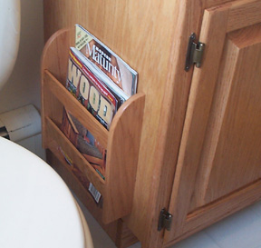
The challenge is cutting the 1/4" mortises in the sides to receive the slats. This is easily done with a mortising attachment on your drill press, and if you haven't attempted this yet, this is a good place to learn it! The time is in the setup, it's very important the square chisel is parallel with the fence. You will also need to adjust the relationship between the square chisel and the drill bit inside. If the bit is too far below the chisel, it will be hard to line up your cuts. If it's too far inside, it will be tough pushing the chisel down into your work piece. Trial and error! The pic at left shows an example on a scrap piece i did to line up the fence.
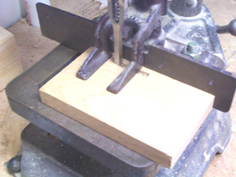
Here's the completed rack. It's only 12" high and 11" wide. The shelf to step up the magazines is behind the lower slat. Round over the sides with a 1/8" round over bit, inside and out.
