Teddy Bear Bookends
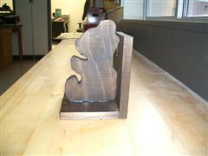
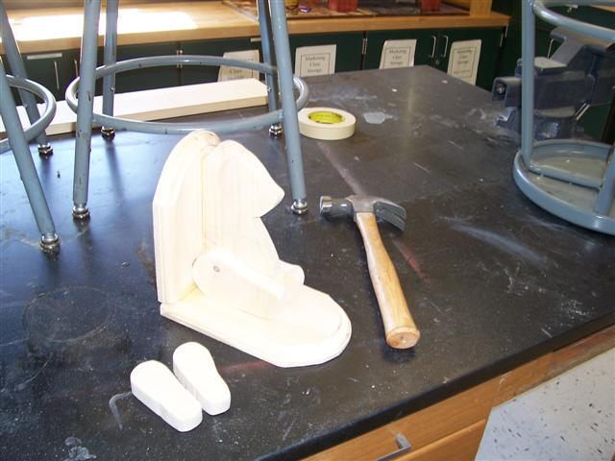
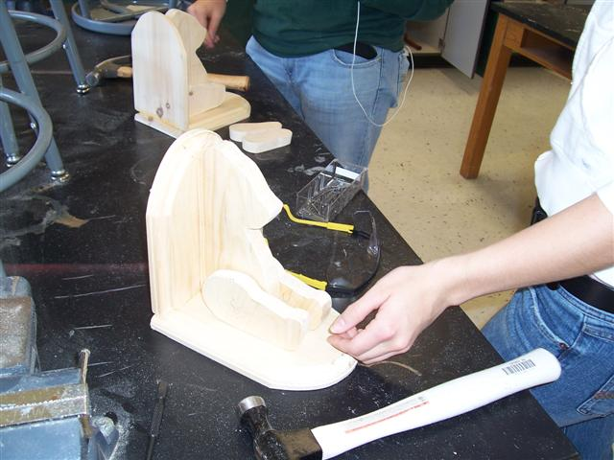
Tools Required
- Pencil
- Saw*
- 8p finishing nails
- Carpenter's square
- Brushes
- Hammer
- Clean rags
- 12" square of felt
- Medium grade sandpaper
- Transparent tape or rubber cement
- Professional Strength Wood Glue
- Water-filled metal container for disposal of oil-soaked rags
Materials Required
- 14" piece of 1" x 6" pine
- 26" piece of 1" x 6" pine
Bears
Step 1: Enlarge bear patterns if not already done
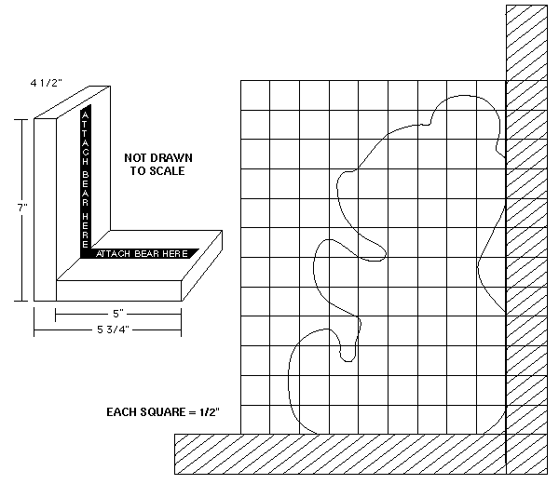
Step 2: Cut the 14" piece of 1 " X 6" pine to form 2 pieces, each 7" long.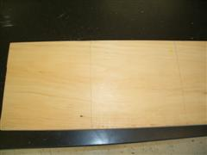
Step 3: Using tape or rubber cement, secure bear pattern to each 7" piece of pine.
Step 4: Cut out bears. NOTE: Back and bottom of bear must form a 90-degree angle.
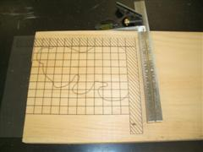
Step 5: Sand both bears smooth. Set aside.
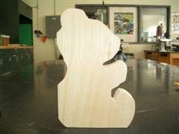
Bookends
Step 1: From the 26" piece of 1" X 6" pine, cut 2 rectangles, each 4"1/2" X 5", and 2 rectangles, each 4-1/2" X 7".
Step 2: Sand smooth.
Assembly
Step 1: Glue and nail the rectangles together to form 2 L-shaped bookends. NOTE: See Assembly Diagrams. Note that the end of the horizontal board is attached to the face of the vertical board.
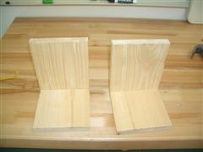
Step 2: Glue and nail a bear to the center of each bookend. (See Assembly Diagrams: shown as shaded area .)
Conditioning. Staining and Finishing
Step 1: Remove all evidence of sanding dust from pieces.
Step 2: Since working with a softwood, pre-treat with Minwax® Pre-Stain Wood Conditioner.
Step 3: For a contemporary look, apply Minwax Pastels® with a brush or rag following label directions. Wait at least 24 hours and then apply Minwax® Polycrylic® Protective Finish. Do not use a polyurethane finish since it tends to amber and distort the pastel color.
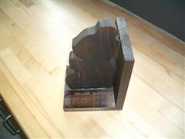
Bottom
Step 1: Cut 2 pieces of felt 4 1/2" X 5"
Step 2: Glue to bottom of bookends
