Elevated Dog Feeder
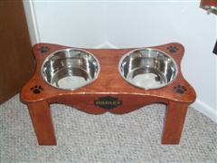
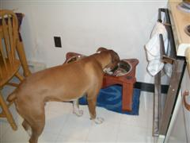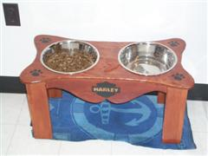
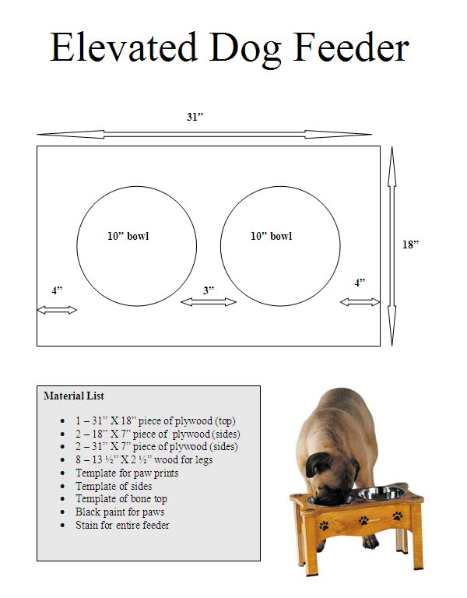
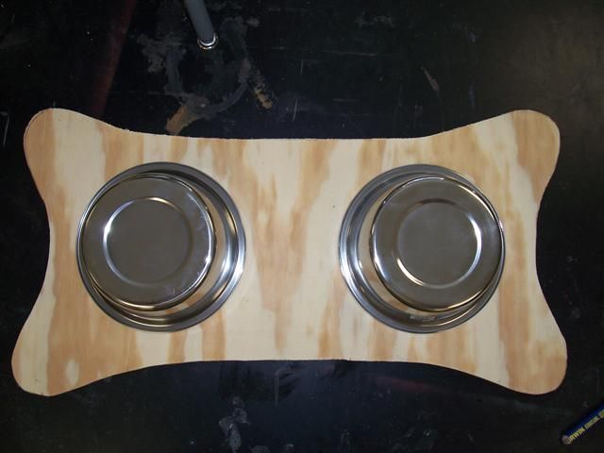
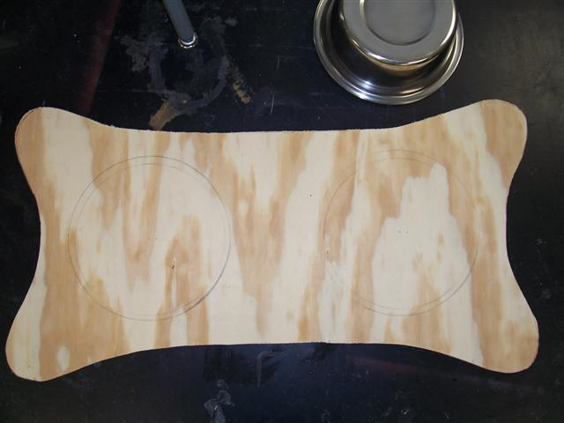
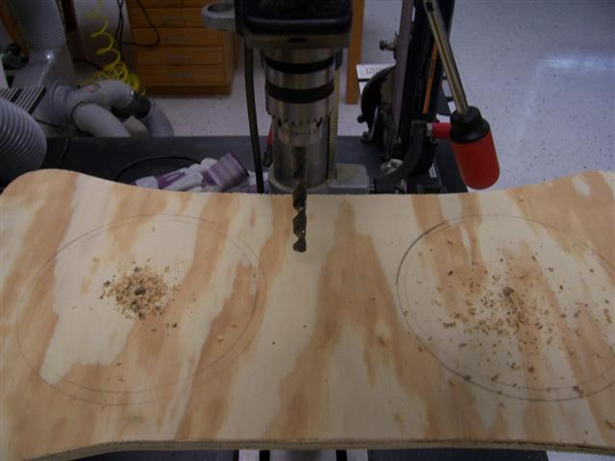
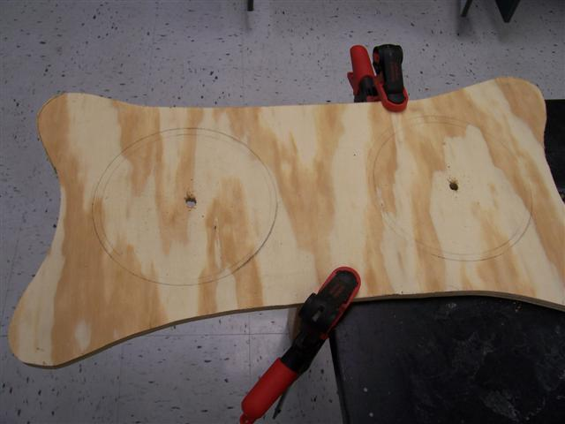
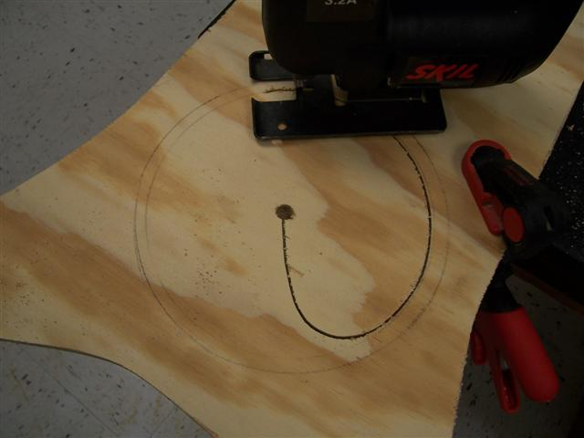
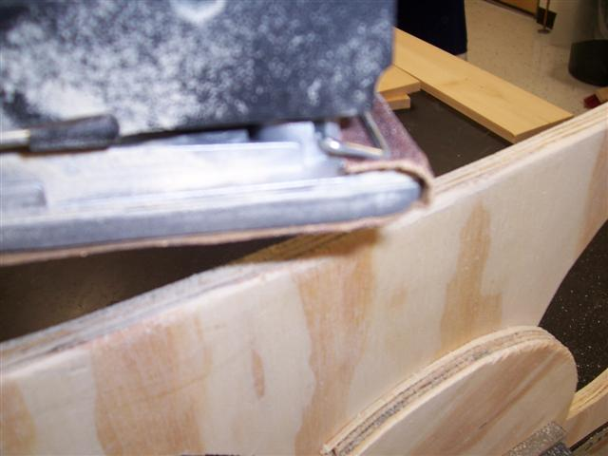
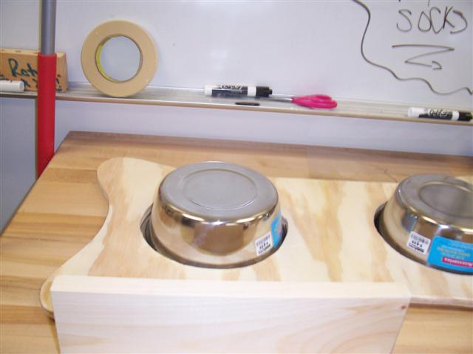
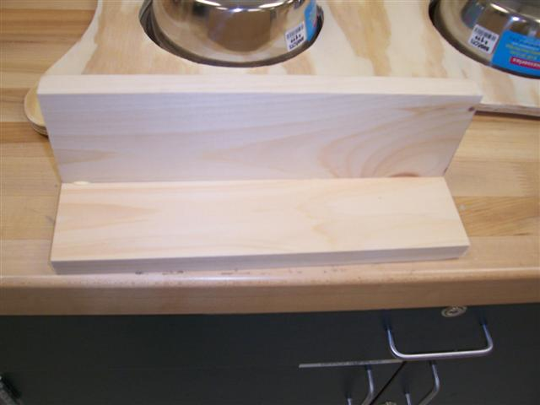
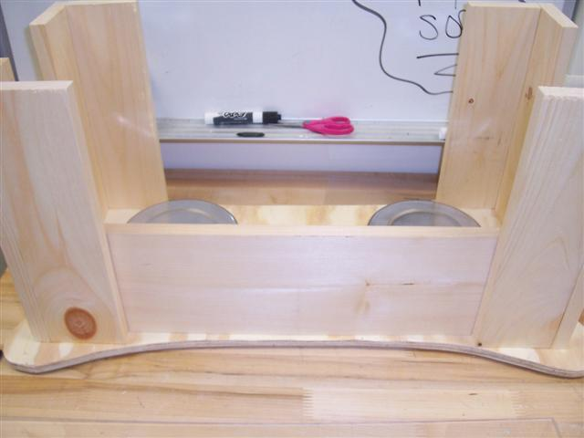
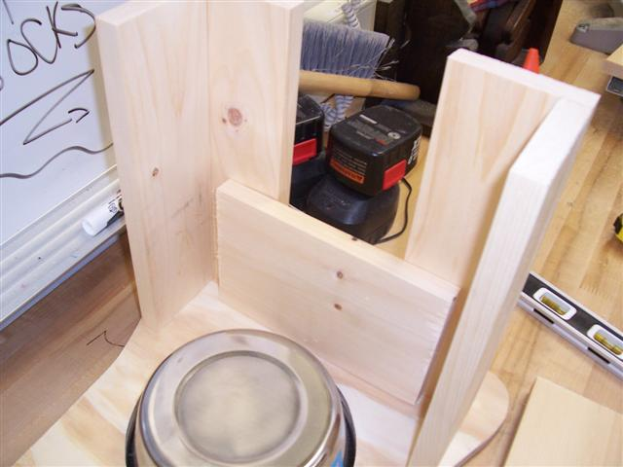
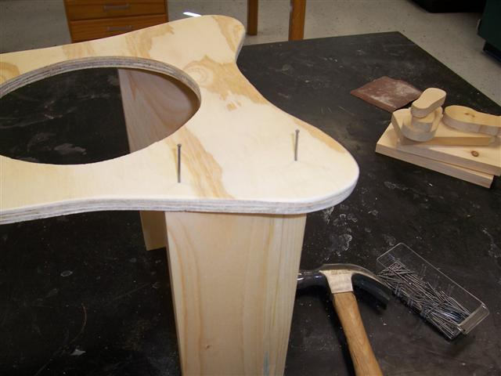
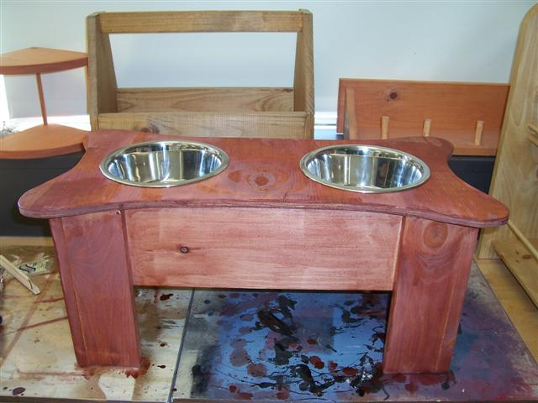

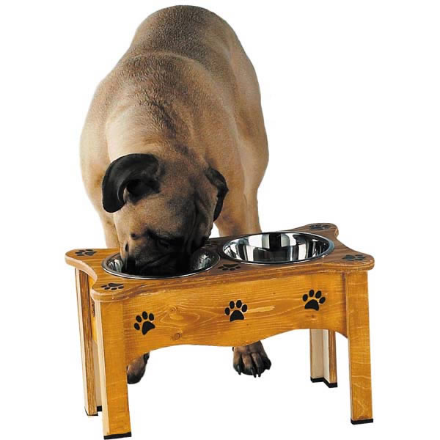
Dog Feeder Rubric
Plans - 100 points
Objective | Possible Points | Your Grade
Plans are descriptive | 20
Adequate drawing to describe process | 20
All Materials listed | 20
Measurements correct | 20
Time on task | 20
TOTAL | 100
Building Process - 500 points
Objective | Possible Points | Your Grade
Edges square | 20
Broken tool - minus 20 points for a blade, 50 for everything else | 50
Circles perfect - in correct location | 20
Measurements exact | 50
Bone template cutout | 30
Side template cutout | 30
Fooling around | 50
Staining - evenly done | 20
Paw prints painted correctly | 25
Legs are same length - project level | 30
Sanded or routered | 35
Cleaned up everytime - minus 10 per day | 50
Nail used correctly - dents, extra holes - 10 each | 30
Wasted material or had to redo something | 50
TOTAL | 500

